
Alpha Pregnancy Resource Center
Special Christmas Project

Christmas is approaching quickly. This is a great time for all of us to take a look at how richly God has blessed each and every one of our lives. Every year we try to help others by picking a special Christmas project.

We are asking our school and church families to help us collect items for Alpha Pregnancy Resource Center in Phoenix. This center is part of Christian Life Resources and the Wisconsin Ev. Lutheran Synod. Their first and foremost priority is to witness their faith and spread the gospel through counseling regarding pregnancy options. They also provide assistance, both practical and spiritual, to women during their crucial time of need. The Alpha hot-liners and on-site advocates offer compassion, encouragement, and information to women in need of resources such as doctors, medical clinics, adoption agencies and financial assistance programs. Practical items including diapers, clothing, blankets and formula are also available at no charge.

We, as a family at Emmaus, would like to collect items to give to Alpha Center. On the back of this letter is a list of items that Alpha Center would like to be able to provide to their clients. They range from rattles, booties, and bibs to diapers and formula. Starting next Monday, there will be a box in each classroom where items can be placed. We will be accepting donations through Sunday, Dec. 20th .

Please help us with donating items to the Alpha Pregnancy Resource Center. In turn they will be able to share God’s Word with their clients and help them with some basic necessities for their babies at Christmas. Thank you for your help.

Alpha Pregnancy Resource Center
Special Christmas Project

Christmas is approaching quickly. This is a great time for all of us to take a look at how richly God has blessed each and every one of our lives. Every year we try to help others by picking a special Christmas project.

We are asking our school and church families to help us collect items for Alpha Pregnancy Resource Center in Phoenix. This center is part of Christian Life Resources and the Wisconsin Ev. Lutheran Synod. Their first and foremost priority is to witness their faith and spread the gospel through counseling regarding pregnancy options. They also provide assistance, both practical and spiritual, to women during their crucial time of need. The Alpha hot-liners and on-site advocates offer compassion, encouragement, and information to women in need of resources such as doctors, medical clinics, adoption agencies and financial assistance programs. Practical items including diapers, clothing, blankets and formula are also available at no charge.

We, as a family at Emmaus, would like to collect items to give to Alpha Center. On the back of this letter is a list of items that Alpha Center would like to be able to provide to their clients. They range from rattles, booties, and bibs to diapers and formula. Starting next Monday, there will be a box in each classroom where items can be placed. We will be accepting donations through Sunday, December 20th.

Please help us with donating items to the Alpha Pregnancy Resource Center. In turn they will be able to share God’s Word with their clients and help them with some basic necessities for their babies at Christmas. Thank you for your help.



- Onesies
- Diapers up to size 5
- Small rattle, baby toy, teether
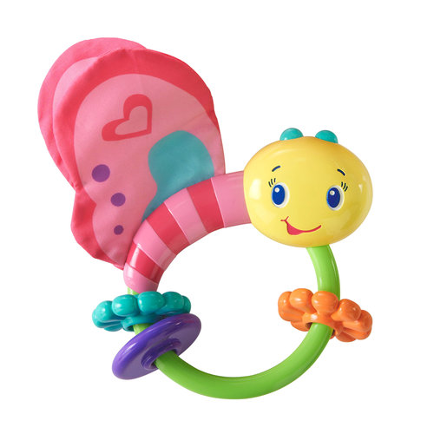
- Similac or other Formula
- Bibs
- Baby wipes
- Baby clothes
- Baby wash clothes/towels
- Baby wash, lotion, shampoo
- Baby blanket
- Hand-made blankets & booties

The above items should be new or in like new condition.

They could also use maternity clothes and
children’s clothes up to size 4T.

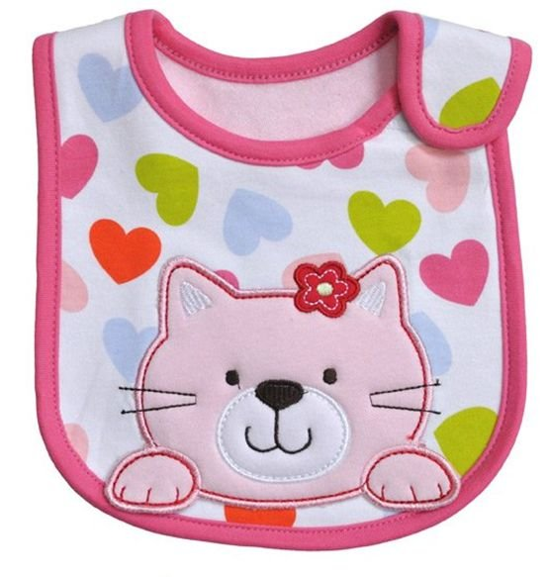

- Onesies
- Diapers up to size 5
- Small rattle, baby toy, teether
- Similac or other Formula
- Bibs
- Baby wipes
- Baby clothes
- Baby wash clothes/towels
- Baby wash, lotion, shampoo
- Baby blanket
- Hand-made blankets & booties

The above items should be new or in like new condition.

They could use maternity clothes and
children’s clothes up to size 4T.

